**Week 4 – Clustering**

**Table of content - Week4**

Summary 1

Milestones achieved 1

Clustering 1

Exploring Multiple Cluster Counts 2

Cluster Evaluation 2

Conclusion 2

How the Feature Selection Helped? 2

Further PCA Explained Variance 2

KMeans 3

GMM - Details 4

Hierarchy - Details 5

Conclusion on Why K-Means is the Best 5

# Summary

The clustering analysis aimed to identify distinct groups within a dataset related to airline passenger satisfaction and loyalty. Various clustering techniques, including KMeans, Gaussian Mixture Models (GMM), and hierarchical clustering, were applied. KMeans emerged as the most effective method, yielding well-separated clusters with clear insights into the data. Despite efforts to optimize GMM and hierarchical clustering, these methods produced inconsistent results that were less interpretable due to overlapping clusters and difficulties in visual separation. This report outlines the milestones achieved, the clustering techniques employed, conclusions drawn, and proposed next steps for further improvement.

# Milestones achieved

We performed 5-fold cross-validation on our KNN model. This indicates that our model performs well and consistently across the different folds, with minimal variation in accuracy between the splits. High accuracy and low standard deviation suggest good generalization and stability of the model.

**Extending:** Data preprocessing & feature selection

## Clustering

* Performed clustering using KMeans, GMM, and hierarchical methods.
* K-Means Clustering: I applied K-Means clustering with 5 clusters to assess how well the data could be separated into distinct groups.
* Silhouette Score: After performing the clustering, I calculated the Silhouette Score, which measures the quality of the clusters. A score close to 1 indicates well-defined clusters, while a score near -1 suggests poor clustering.
* PCA for Visualization: To visualize the clusters, I used PCA (Principal Component Analysis) to reduce the data to two components. This allowed me to visually inspect how the clusters were formed, providing insights into their separation.
* Optimized KMeans using the elbow method and silhouette analysis, identifying 5 as the optimal number of clusters.

## Exploring Multiple Cluster Counts

* I experimented with different numbers of clusters, ranging from 2 to 5, and calculated the silhouette score for each case. This helped me determine the optimal number of clusters by observing how changing the cluster count impacted performance.

## Cluster Evaluation

* Visualized clusters in 2D and 3D plots.
* Compared cluster distributions and evaluated performance metrics such as silhouette scores.

# Conclusion

## How the Feature Selection Helped?

Feature selection played a critical role in addressing the initial challenges encountered with the full dataset. The original dataset contained numerous features, many of which were either redundant or not strongly correlated with the target variable, Loyalty. This redundancy introduced noise, making clustering difficult and leading to suboptimal silhouette scores. By applying a systematic feature selection approach, the dataset was reduced to a focused subset of attributes, including Type of Travel, Online Boarding, and In-flight Wifi Service. These features were identified as highly relevant based on their correlation with the target variable and their importance scores derived from various models. For example, Type of Travel ranked highly across multiple selection methods, emphasizing its predictive power for determining customer loyalty. This refined dataset not only improved clustering results but also reduced computational overhead, making the clustering process more efficient and interpretable. Below is the Sihouette score for different data set where the first one from left is for the compelte dataset, midle one is with the reduced data set and the last one is the reduced data set for PCA. This leaves us to explain the PCA explaiend variance which factors in the % of data i.e being used.

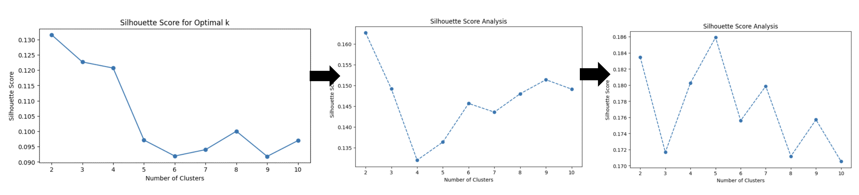

## Further PCA Explained Variance

Principal Component Analysis (PCA) was applied to the selected features to ensure the most significant components of the data were retained while minimizing dimensionality.

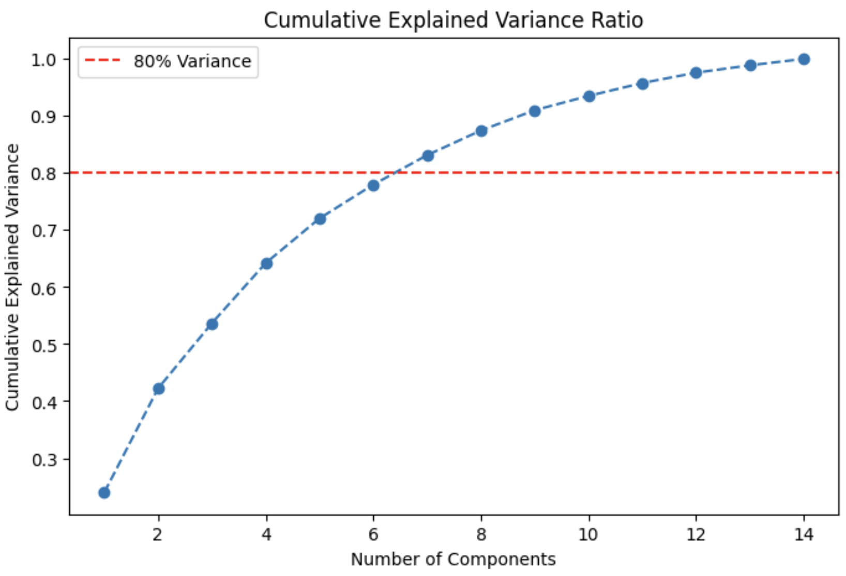

The cumulative explained variance plot showed that eight principal components captured over 80% of the variance in the data, a critical threshold for retaining most of the dataset’s informational content.

PCA helped reduce the dimensionality from 14 selected features to eight components, which improved the clustering’s performance. For instance, after dimensionality reduction, the silhouette score for K-Means peaked at five clusters, demonstrating well-separated and meaningful cluster formation. This reduction not only removed less informative attributes but also enabled visualizations such as 2D and 3D scatter plots, highlighting the cluster structure more clearly.

## KMeans

K-Means clustering provided the most meaningful segmentation of the dataset, identifying five distinct clusters based on the silhouette score. However, visualizing these clusters in 2D or 3D plots was initially challenging. The data’s high dimensionality and complex distribution made it difficult to clearly separate clusters in lower-dimensional representations.

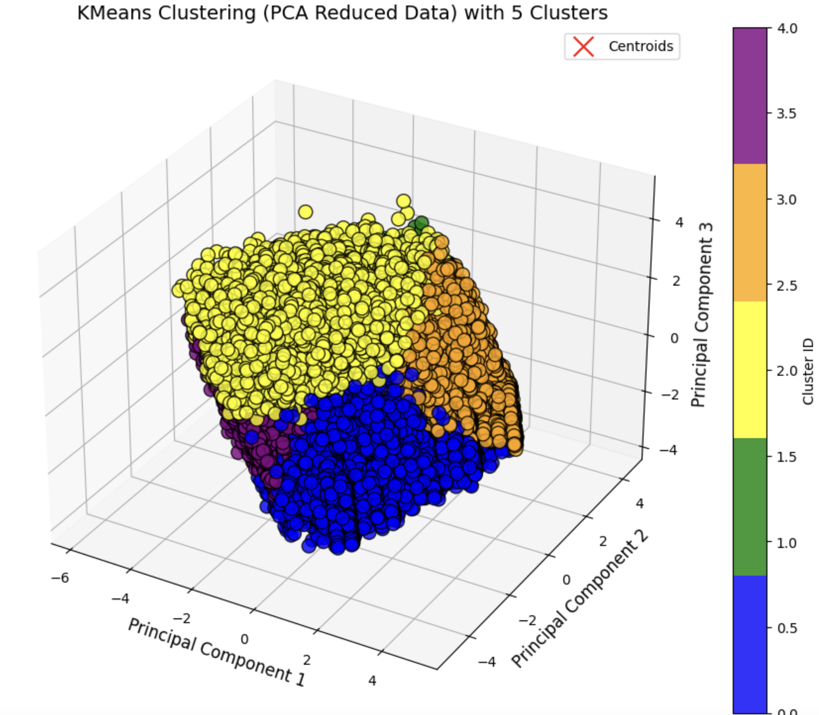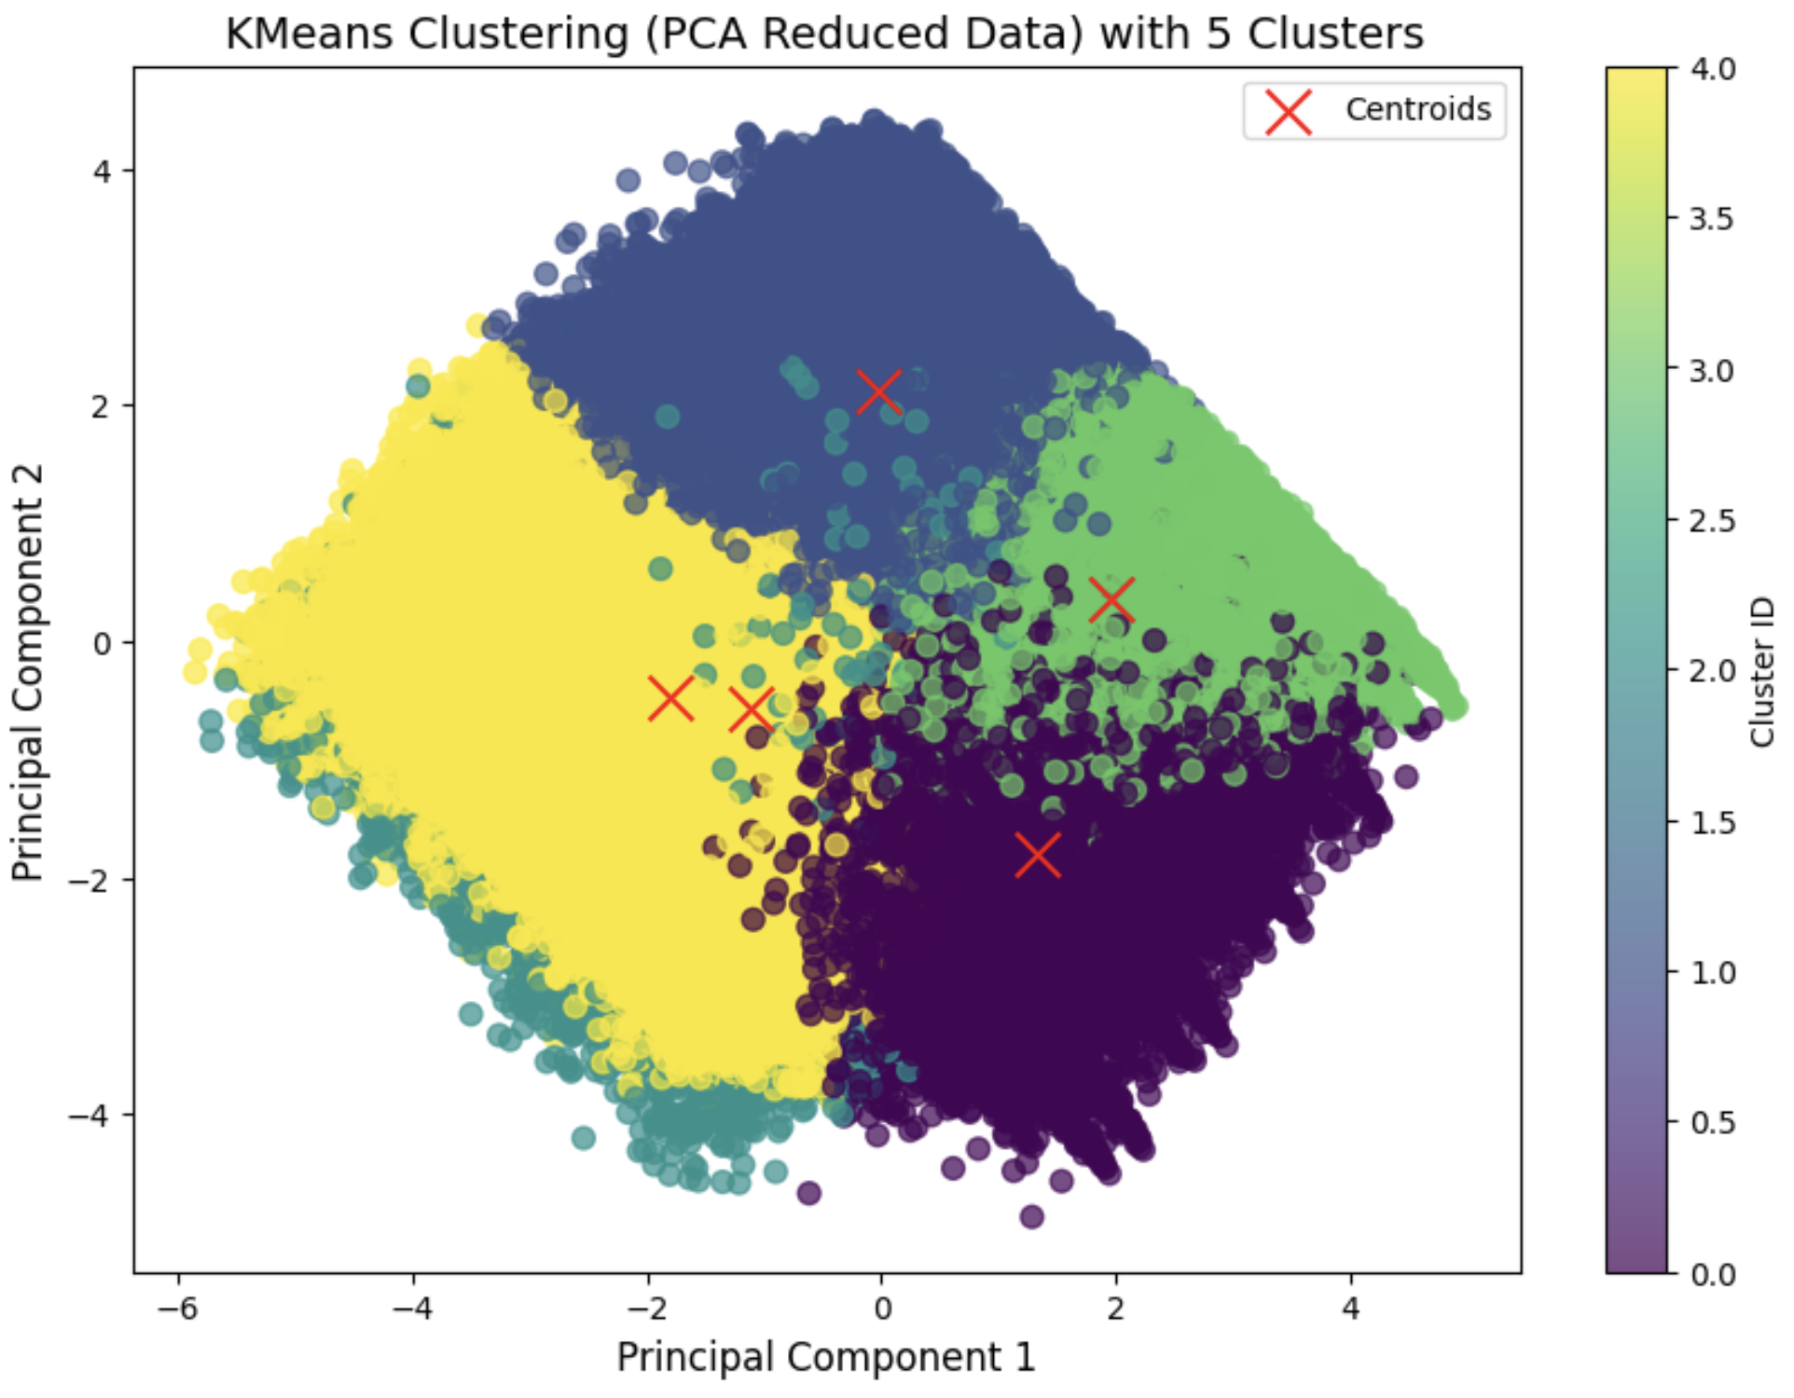

To overcome this, we utilized scatter plots for pairs of principal components derived from PCA-reduced data. The code below demonstrates the use of 3D plots for visualizing cluster separation:

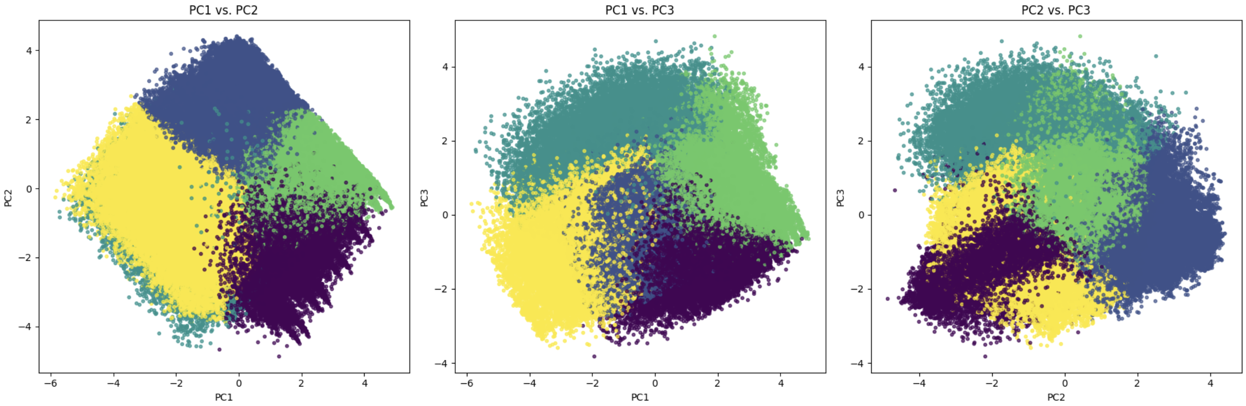

Among the plots generated, the PC1 vs. PC2, PC1 vs. PC3, and PC2 vs. PC3 visualizations revealed subtle patterns in the data that were not apparent in lower-dimensional spaces. The scatter plot for **PC2 vs. PC3** provided the clearest distinction between clusters, showcasing the separation of five distinct groups, particularly for clusters representing loyal and dissatisfied travelers.

This step was pivotal in confirming the efficacy of K-Means clustering for the dataset. It validated that even when 2D or 3D plots seemed ambiguous, the combination of PCA and detailed visual analysis could highlight meaningful segmentation, solidifying the insights gained from clustering.

## GMM - Details

Gaussian Mixture Models (GMM) were also applied to the dataset, but they did not perform as well as K-Means. GMM assumes that the data is generated from a mixture of Gaussian distributions, which may not align with the dataset’s underlying characteristics. This discrepancy was evident in the silhouette score analysis, where GMM failed to achieve a meaningful peak, even at five clusters.

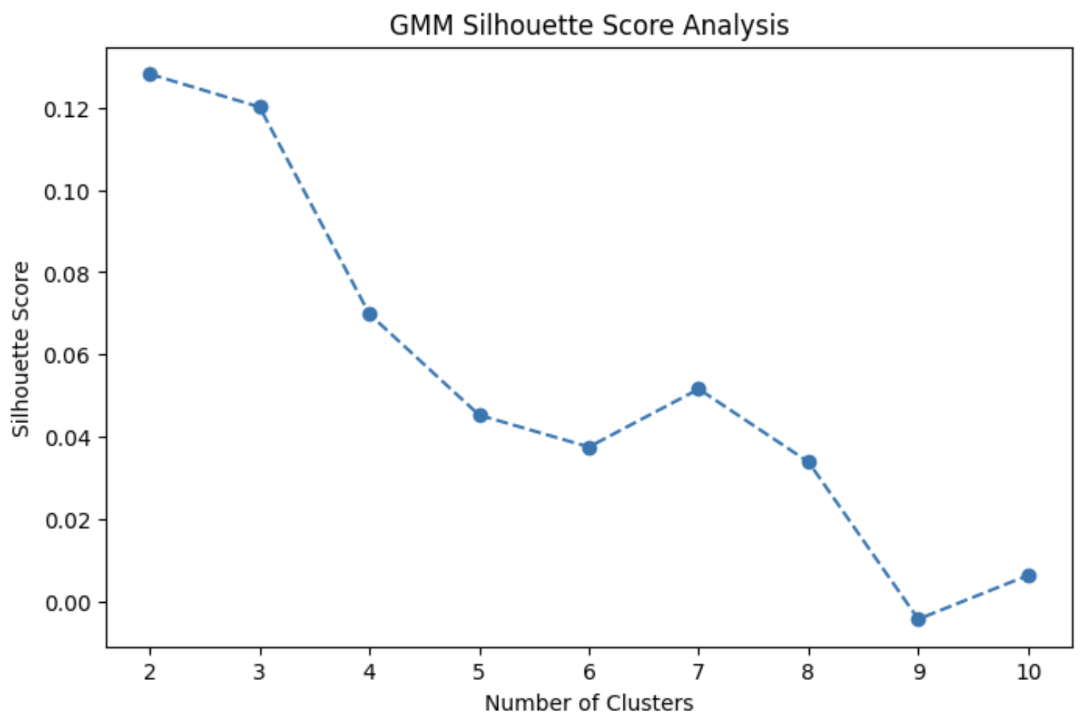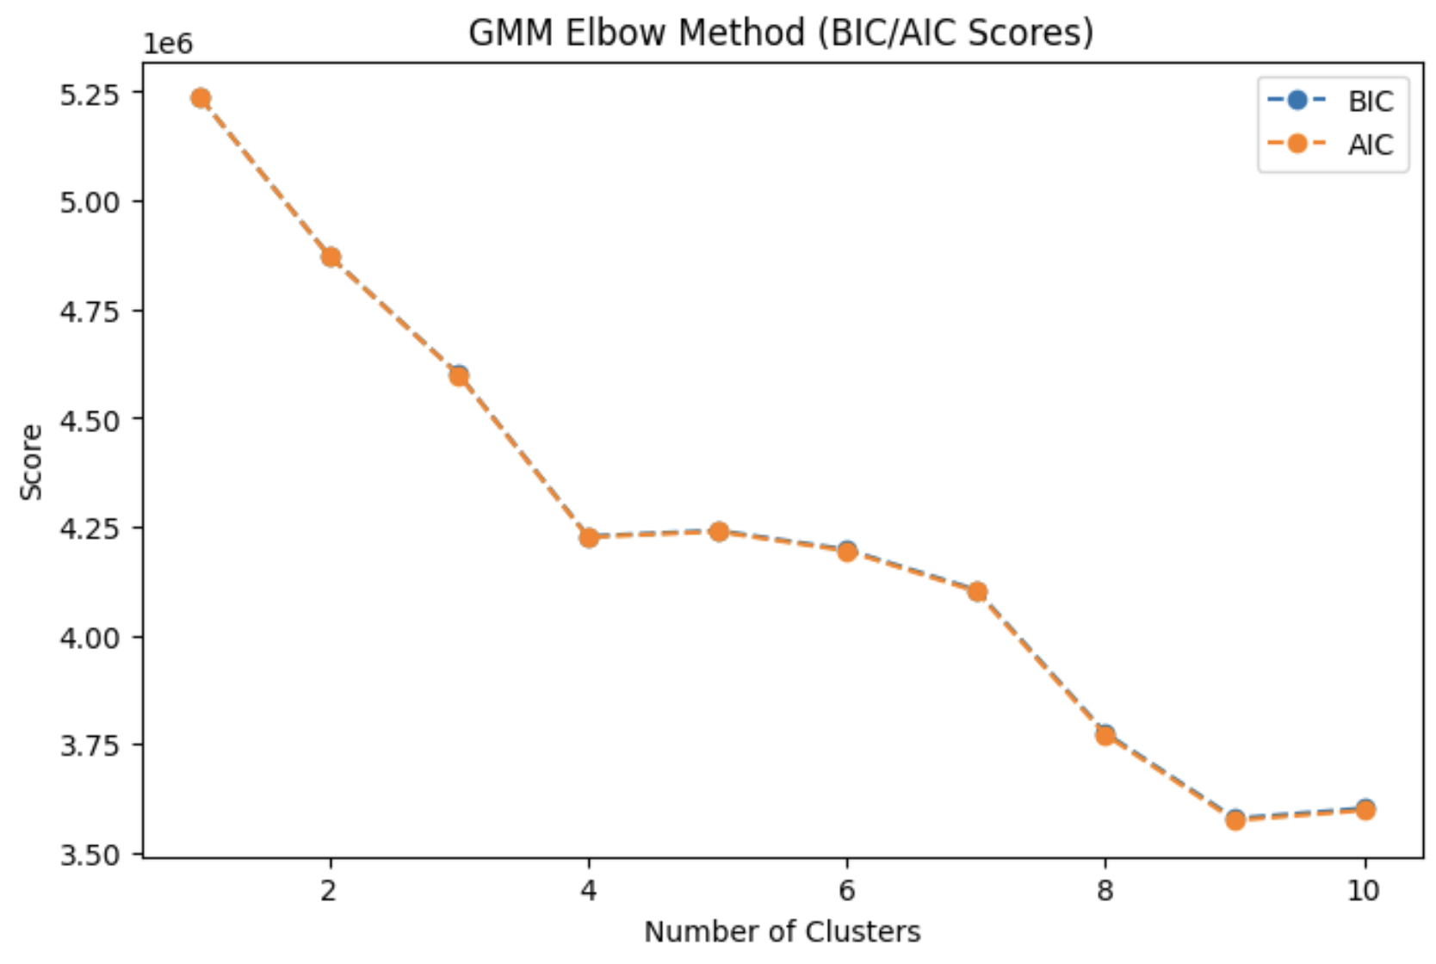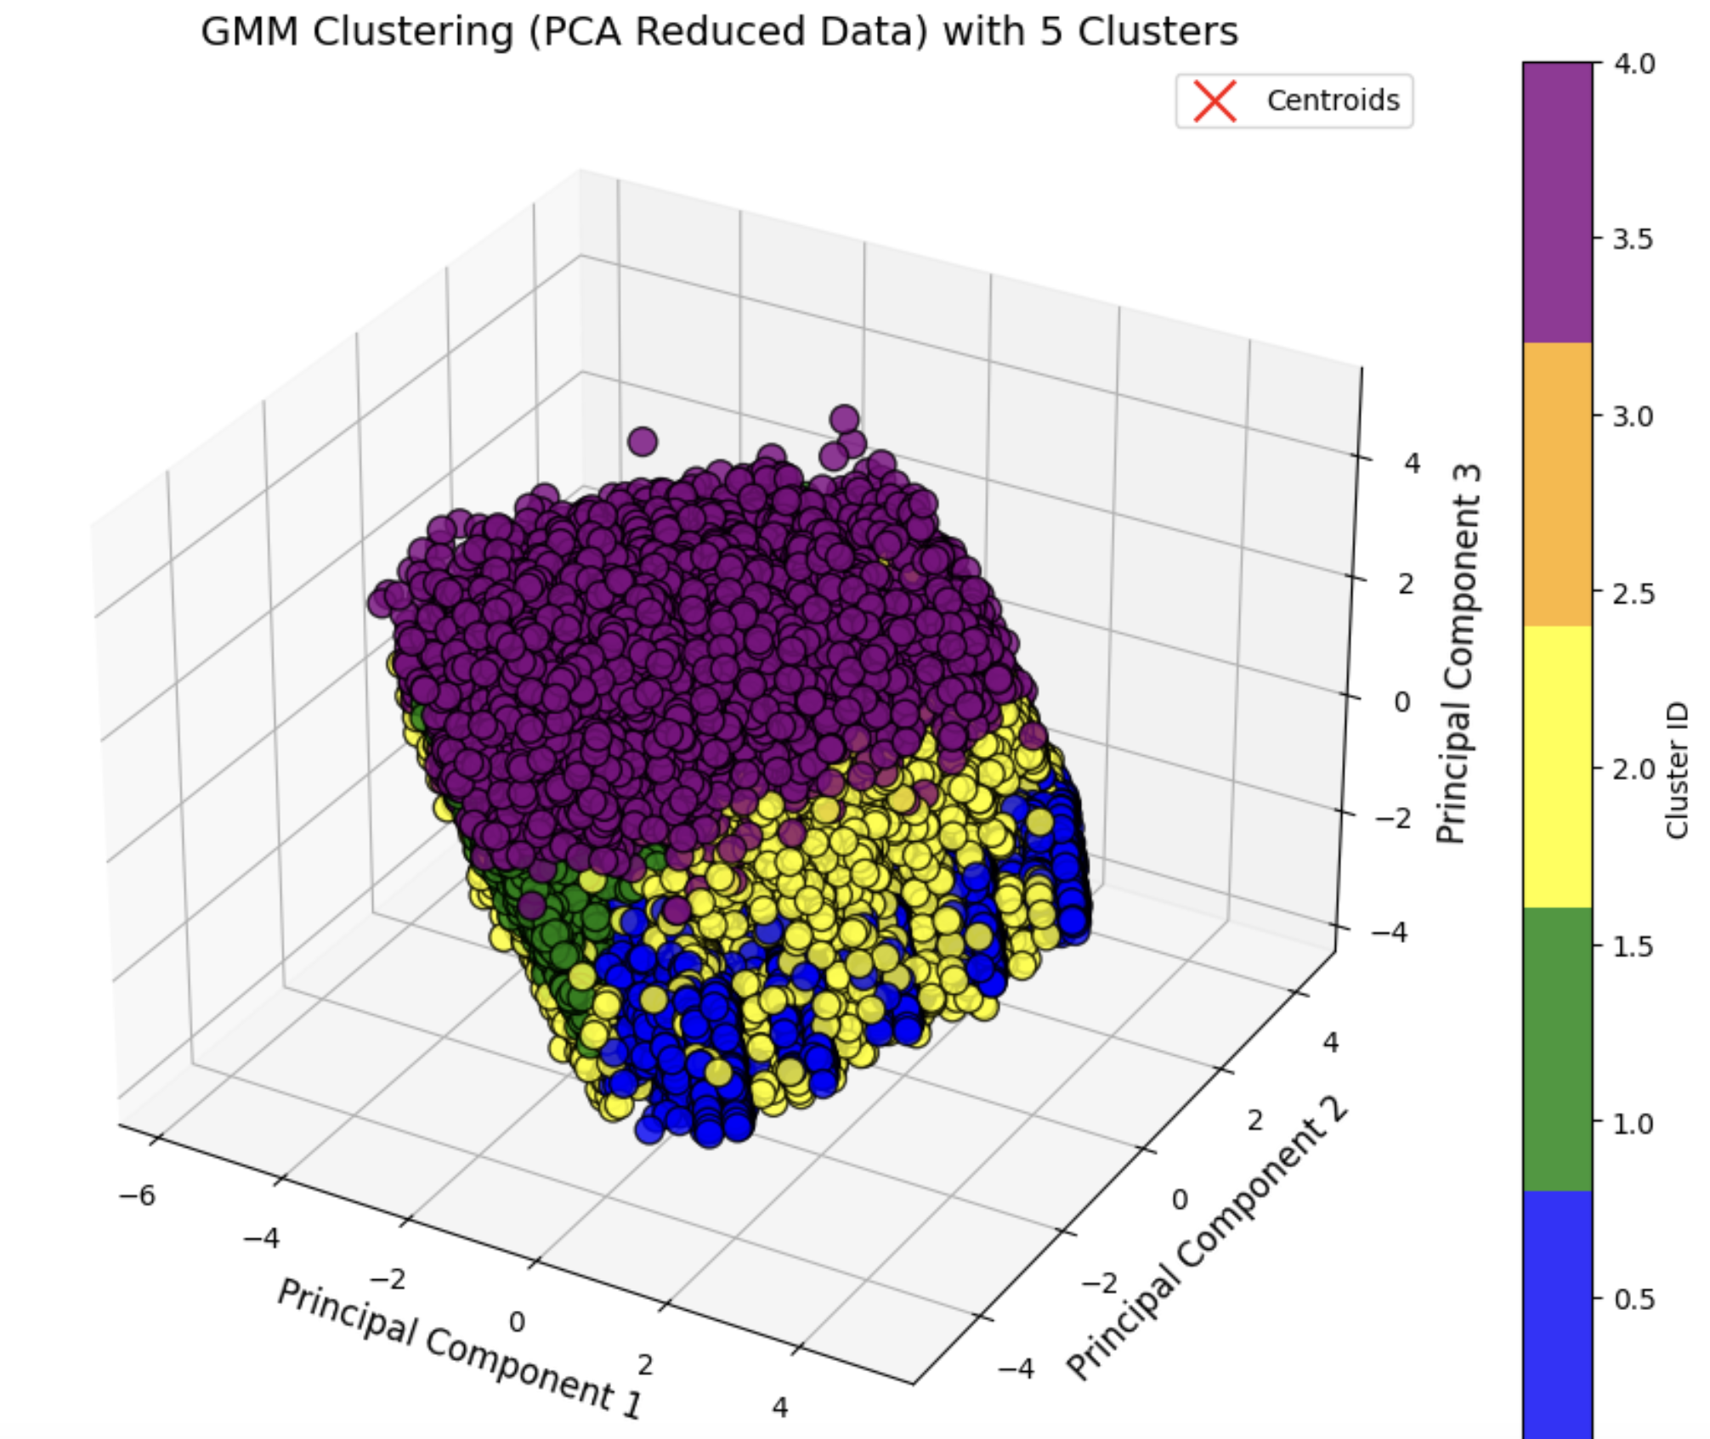

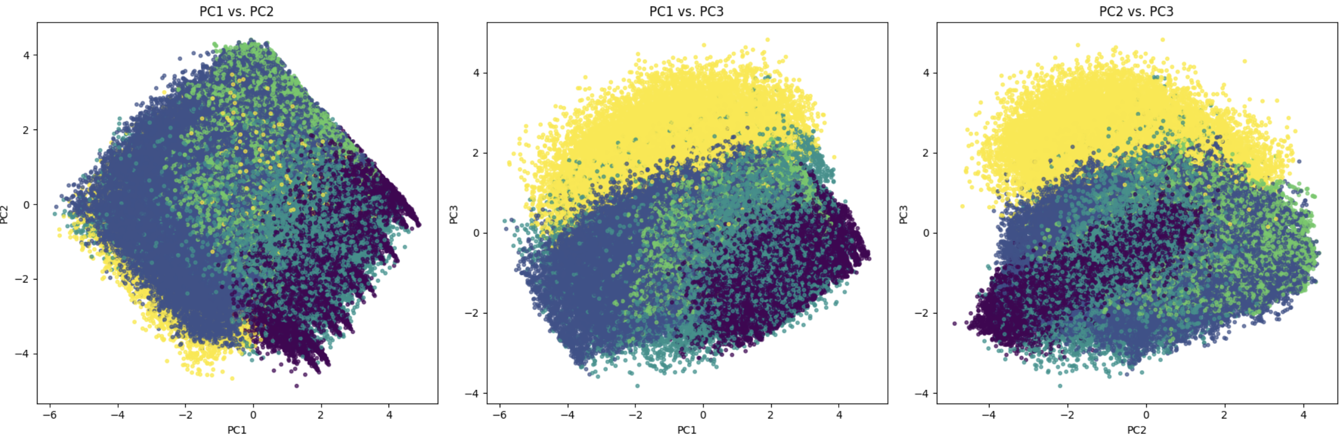

For instance, GMM struggled to define clear boundaries between clusters, as observed in the scatter plots above. Unlike K-Means, which maintained consistent cluster shapes and sizes, GMM resulted in overlapping clusters. For example, clusters containing customers with medium satisfaction levels were often merged with other groups, reducing the interpretability of the results. This limitation made GMM less effective in identifying well-separated clusters.

## Hierarchy - Details

Hierarchical clustering was explored as a complementary approach to segment the dataset. Using the Ward linkage method, dendrograms were created to visualize the hierarchical structure of the data. While the dendrograms provided an insightful representation of relationships among data points, the clustering results were not as well-defined as those from K-Means.

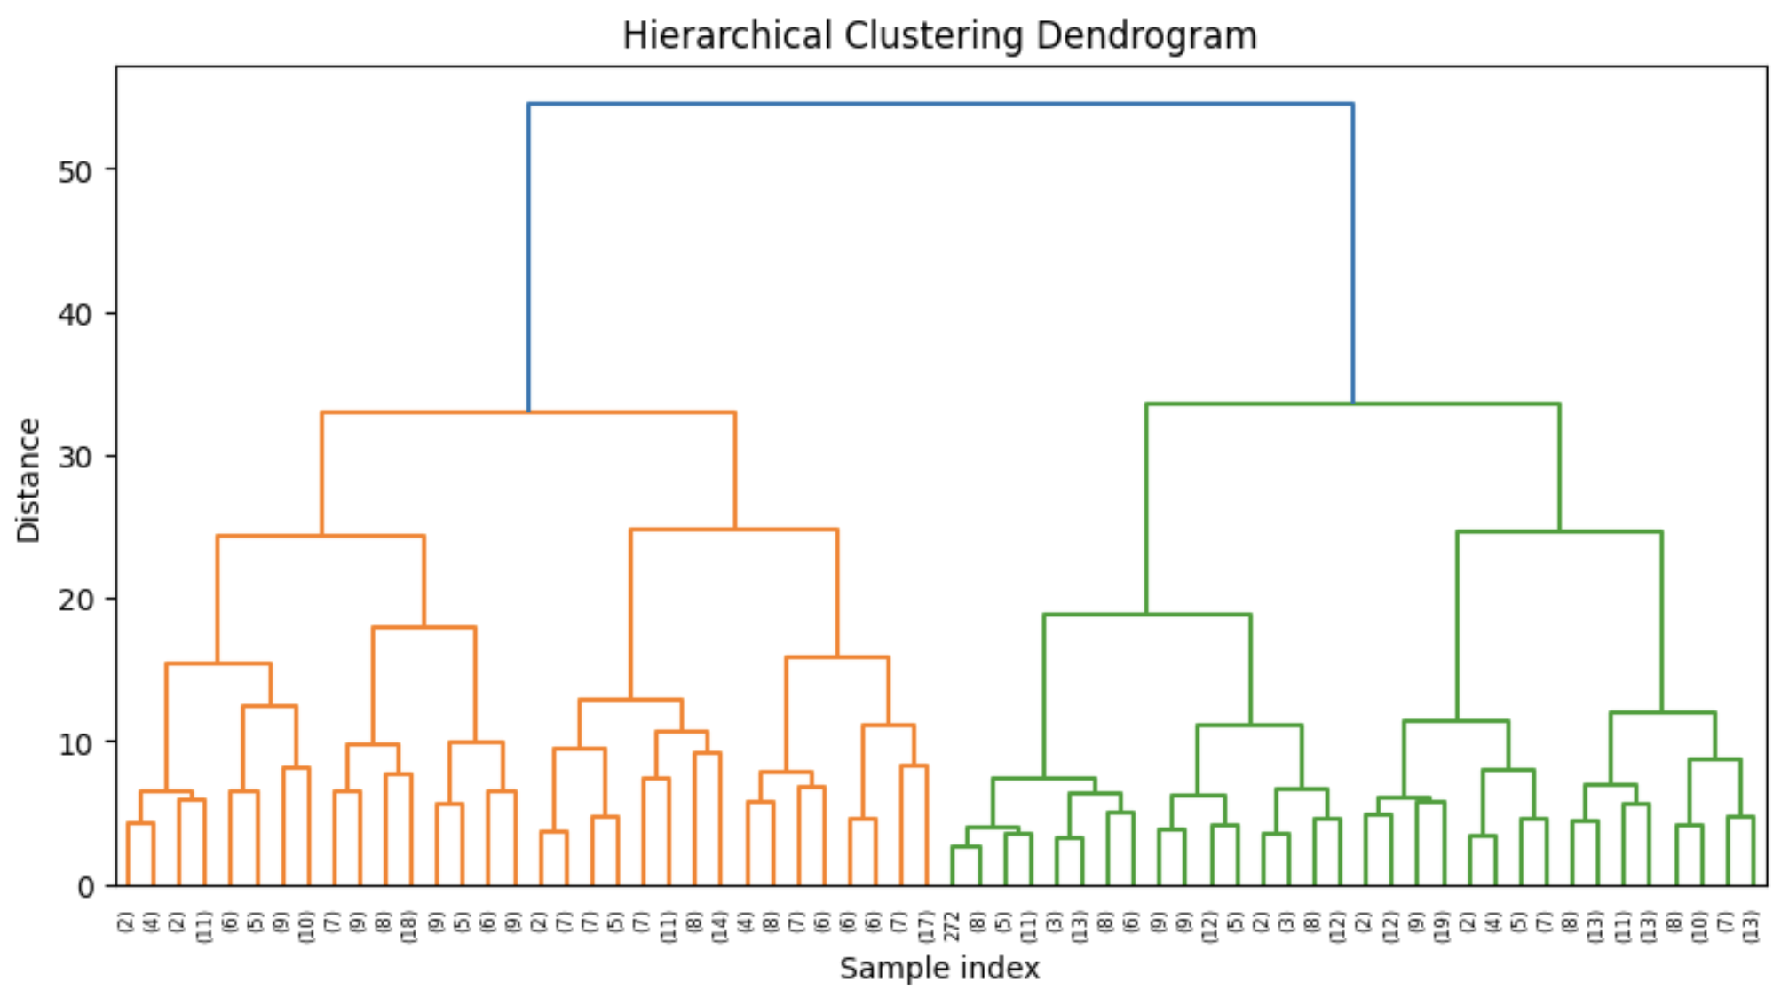

## Conclusion on Why K-Means is the Best

K-Means emerged as the most effective clustering method due to its ability to create distinct and interpretable clusters. The silhouette score analysis consistently showed a peak at five clusters, confirming the validity of the segmentation. These five clusters revealed meaningful customer profiles:

* **Cluster 0:** Customers with high in-flight comfort and minimal delays, often business travelers.
* **Cluster 1:** Satisfied economy travelers with moderate online boarding scores.
* **Cluster 2:** Younger customers with moderate satisfaction scores and shorter flight distances.
* **Cluster 3:** Dissatisfied economy travelers with higher delays and lower comfort.
* **Cluster 4:** Loyal business travelers with high satisfaction across all metrics.

The combination of PCA-reduced dimensions, feature selection, and K-Means clustering ensured that the segmentation was robust and actionable. By focusing on meaningful attributes, such as Type of Travel and Online Boarding, K-Means successfully segmented the customer base into groups that align with loyalty trends, making it the preferred method for this analysis.

**Next Steps**

* Feature selected data must be taken up further for model creations

**References**

* Géron, A 2022, Hands-On Machine Learning with Scikit-Learn, Keras, and TensorFlow, O’Reilly Media, Incorporated, Sebastopol.
* Kaggle Dataset: Airline Passenger Satisfaction. Available at: <https://www.kaggle.com/datasets/teejmahal20/airline-passenger-satisfaction/data>
* ProQuest Ebook Central: Géron, A. Hands-On Machine Learning [Accessed 29 September 2024].
* KDnuggets: Feature Selection Overview. Available at: <https://www.kdnuggets.com/2021/06/feature-selection-overview.html>
* Scikit-Learn Documentation: PCA and Clustering. Available at: <https://scikit-learn.org/stable/modules/generated/sklearn.feature_selection.SelectKBest.html#sklearn.feature_selection.SelectKBest>
* GitHub Repository: Hands-On Machine Learning Project. Available at: <https://github.com/ageron/handsonml2/blob/master/02_end_to_end_machine_learning_project.ipynb>.
* Pedregosa, F., Varoquaux, G., Gramfort, A., Michel, V., Thirion, B., Grisel, O., Blondel, M., Prettenhofer, P., Weiss, R., Dubourg, V., Vanderplas, J., Passos, A., Cournapeau, D., Brucher, M., Perrot, M. & Duchesnay, É., 2011. Scikit-learn: Machine Learning in Python. *Journal of Machine Learning Research*, 12, pp.2825–2830. Available at: <https://scikit-learn.org/stable/modules/clustering.html> [Accessed 21 November 2024].
* Géron, A., 2022. *Hands-On Machine Learning with Scikit-Learn, Keras, and TensorFlow*. O’Reilly Media, Sebastopol.
* Tan, P.-N., Steinbach, M. & Kumar, V., 2019. *Introduction to Data Mining*. Pearson Education.
* Towards Data Science, 2020. Clustering Visualization in Python: How to Spot Patterns in Data. *Towards Data Science*. Available at: <https://towardsdatascience.com/clustering-visualization-in-python-dc2b4a7c1b3e> [Accessed 21 November 2024].
* Tan, P.-N., Steinbach, M. & Kumar, V., 2021. Introduction to Data Mining. Available at: https://dataminingbook.info/book_html/ [Accessed 21 November 2024].
* Displayr, 2024. Understanding Cluster Analysis: A Comprehensive Guide. Available at: <https://www.displayr.com/understanding-cluster-analysis-a-comprehensive-guide/> [Accessed 21 November 2024].
* Google Colab, 2024. Interactive Python Notebook for Clustering Analysis. Available at: <https://colab.research.google.com/drive/1JagU9RWa_dCVsposeZTCt5VyoVuXfisb?usp=sharing> [Accessed 21 November 2024].